LANNY A.K.A GREEN MOUNTAIN BOY – “GREENS” DELAWARE AND NEW JERSEY

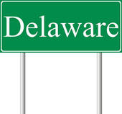
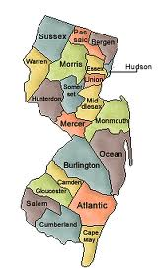

Lanny Wexler; a.k.a Green Mountain Boy "greened" the states of Delaware and New Jersey on March 30 and 31 making them his sixth and seventh state of total completion by finishing his 17 year quest to complete visitations to the highest points in all three Delaware Counties and all 21 New Jersey Counties. The completion of the Delaware and New Jersey COHPS erased a 14 year “journey in the wilderness” at the "hands" of Judge Bill Jacobs and Judge Fred Lobdell when Lanny was read "The Rules" after laying claim to these states under a mistaken notion that I only had to visit one point to "claim" a County. I learned the "hard way" one point completions in Counties with multiple "COHPs don't count!
Lanny was "stripped" of some 40+ counties and demoted down in the list of COHP contenders in 1998. So now some 14 years later, Lanny just “made right" his COHP claims and restored "his honor" as a serious COHPer. Lanny has grown to accept risk which means doing "multiples" and occasionally "going private" when circumstances dictate.
So let’s "cut to the chase" and get on with this trip report. In addition to County Highpointing Lanny is working on the Appalachian Trail (AT) as a section hiker. Lanny has hiked over 1,000 miles (45%) of the AT over some 22 years. As many of you might know; a fair number of county highpoints are on or near the AT.
Definitely, not Delaware and definitely not most of New Jersey but since Lanny was heading south to do a section of the AT Lanny figured he could swing over to New Jersey and Delaware on the way there or the way back.

Sunday March 25, 2012 - Jefferson County, WV COHP #207 spot el 4,700 feet SW of Wilson Gap el. 1,713 feet
Take VA 7 to Round Hill, VA about 50 miles west of Washington DC on the east side of the Blue Ridge Mountains. Take VA 719 north about three miles to Appalachian Drive where you turn left. After going about a mile turn right and cross small bridge, there will be signs for Blackburn Trail Center. The road becomes dirt with a steep grade. This is definitely drivable by a passenger car though my wimpy Prius almost stalled on one of the grades till I floored the accelerator. My two friends and I started at the Blackburn Trail Center and would hike the AT seven miles to VA 7 near Bluemont. The hike started under cloudy skies about 60 degrees with sun breaking through later. After climbing up to the AT from the hostel attaining the ridge the AT drops into Wilson Gap then climbs back up. At first, I thought the County high point was among some rock out croppings perhaps 50 feet off the trail with a limited view to the east, I soon found out that was wrong. As I headed south a ridge off to the right (west) rose distinctly. I headed up the ridge and bushwacked through open woods walking perhaps a quarter mile to ensure I covered all of the highest ground . Little time was lost as I was walking south any way, paralleling the AT that was perhaps 100 feet below me. I then followed the AT south over an undulating trail through a section known as the Devils Racecourse. There was an impressive view of the greening Shenandoah Valley from the Crescent Rock overlook.

Monday March 26, 2012 – Mt Weather, Loudon County, VA
While Mt Weather is not the Loudon highpoint an incident that occurred at the entrance to the Mt Weather facility affected my access to the Loudon County highpoint some three miles to the south forcing me to postpone my visit by a day. Monday was a crisp, dry windy day. My friends and I were going to attempt o hike fourteen miles of the AT from VA 7 to US 50 in Ashby Gap. Two of my friends were quite slow and the logistics of the car shuttle were complicated because we were planning to leave a second car at the midpoint of the hike for those who could not go the distance. I soon discovered to reach road at the mid point of the hike was on a dirt road with a very steep grade that required a SUV with four wheel drive to make the steep grade. Based on what happened to my car yesterday I wouldn’t dream of bringing my car up that road.

The AT through this section crosses a series of ravines and as a result earns the title of the AT rollercoaster as it relentlessly climbs and descends and does not stay on the ridge like it does most everywhere else. The high ridge to the east has wealthy private homes fronting on VA 601 and at the midpoint of that ridge sits Mt Weather. Mt Weather as I was soon to find out was an Emergency Operations Center for the federal government where the President or the Congress could go if there were a nuclear attack.
About 3 pm we reached the dirt road where my friend’s SUV was parked. There was room for only one person in his messy SUV. My other two friends decided to walk up to VA 601 on this dirt road. They figured it was only a mile and a quarter to reach VA 601 and by the time they reach VA 601 I would have the car and pick them up to take them back to their cars. What they didn’t know was they had to climb 1,000 feet steeply from the AT trailhead up to VA 601. One of my friends was beat already and the 1,000 foot climb would be an ordeal for him. It so happened this dirt road that leads up to VA 601 crosses beyond to the front gate of the fenced and guarded Mt Weather Emergency Operations Center. When I reached my car I drove over there to pick my friends up. As I approach the meeting spot I see no one has arrived yet.
I pull over on the left at a grass pullover opposite the gate to Mt Weather, just across the road to wait for them. I knew right away even though I wasn’t on government property or private land my presence here would draw attention and sure enough I was right. It was about 5 pm and people leaving work at Mt Weather were giving me long stares trying to figure out what I was doing there. Was I a terrorist scoping out the place?
A federal police officer comes over to my car and asks me to come out and asked me why I was stopped here. I explained I my friends and I were hiking the AT and were unable to complete this entire section and that I had arranged to meet my friends here. The federal officer asked to see some ID and asked why I couldn’t drive down the dirt road. I explained to him in my car it was unsafe to travel that road. He asked for my friend’s names and where they lived. A female agent came over in a SUV. The federal officer explained to her what I told him and she set out to find my friends to verify if I had been truthful.
The federal officer seemed to soften up a bit and asked me about my hike. I explained I had hiked the AT all the way from northern Virginia to western Maine. The female agent came back without my friends and when I asked why the officer explained she was not permitted to pick anyone up. She saw my friends and said one of my friends was having a difficult time with the hill as it was perhaps a 1,000 foot climb from the AT to where we are on VA 601 at the entrance to the Mt Weather facility but that they would be here in five minutes.

As my friends arrived, trudging up the road, the female agent asked if my friends were ok and if they needed water. They said they were ok, just tired.
I scolded my friends for not listening to me and walking out the other way which would have avoided this into making this a “national security incident”.
Of course now that I had “been seen” it made me very leery to attempt the Loudon County highpoint that day. After dropping my friends off on VA 7 I had to drive back on VA 601 south and go right by Mt Weather again. The Loudon County HP was another three miles down VA 601 and I would be parking along the side of VA 601 to make my “quick dash” to attain Loudon. I felt “all eyes” were on my Prius.
Sure enough as I drove by the front gate of Mt Weather, a white pickup gate came out the gate and was on my tail all the way to US 50. I was in no mood to even stop slowing down and pulling over to do Loudon County. I had been “warned”. No more “warning” next time. I wisely continued past the driveway to the house and d tower and came back the next day to do my deed.
Tuesday March 27, 2012 Loudon County, VA/Clarke County, VA #208 & #209 two areas Blue Mt 1,920 ft Fauqier County, VA #210
After completing my AT hike this afternoon at US 50 Ashby Gap, I drove north on VA 601 for three miles from US 50 first passing the radar tower and then stopping at the driveway leading to the private house to the north. I did my “quick dash” to the two areas of the Loudon/Clarke County HP which meant stopping along the side of VA#601, a hurried walk up the driveway, gratefully finding no one home walking around the house in search of the highest ground and making my way to the obvious rock outcrop to the southwest between the house and the tower to claim the high ground of Loudon County, VA.
Phew! Loudon County was behind me now I can set off for the southern area of Clarke County and Fauqier County. Though it was fairly late in the day perhaps 6 pm both Clarke and Fauqier went smoothly in fact a lot easier than the trip descriptions indicated. I made my way south to VA 55 which parallels I-66. I found VA 638 which is a good paved road passing through suburban divisions. Along the way I passed the Fauquier highpoint at the intersection with Allegheny Road at the 5.4 mile mark. I drove right past Fauqier HP as I decided since this was the easier of the two and it was getting late best to finish off Clarke first. At about six miles from VA 55 I continued straight on a good dirt road called Fire Trail road. I continued to mile 7.8 from VA 55 and found the dirt trail to the right leading the short distance up to the Clarke County highpoint, southern area. I walked the road up to a clearing, where the remains of a metal roof were perched on a rock at the obvious high point. I snapped a few photos and returned to my car.
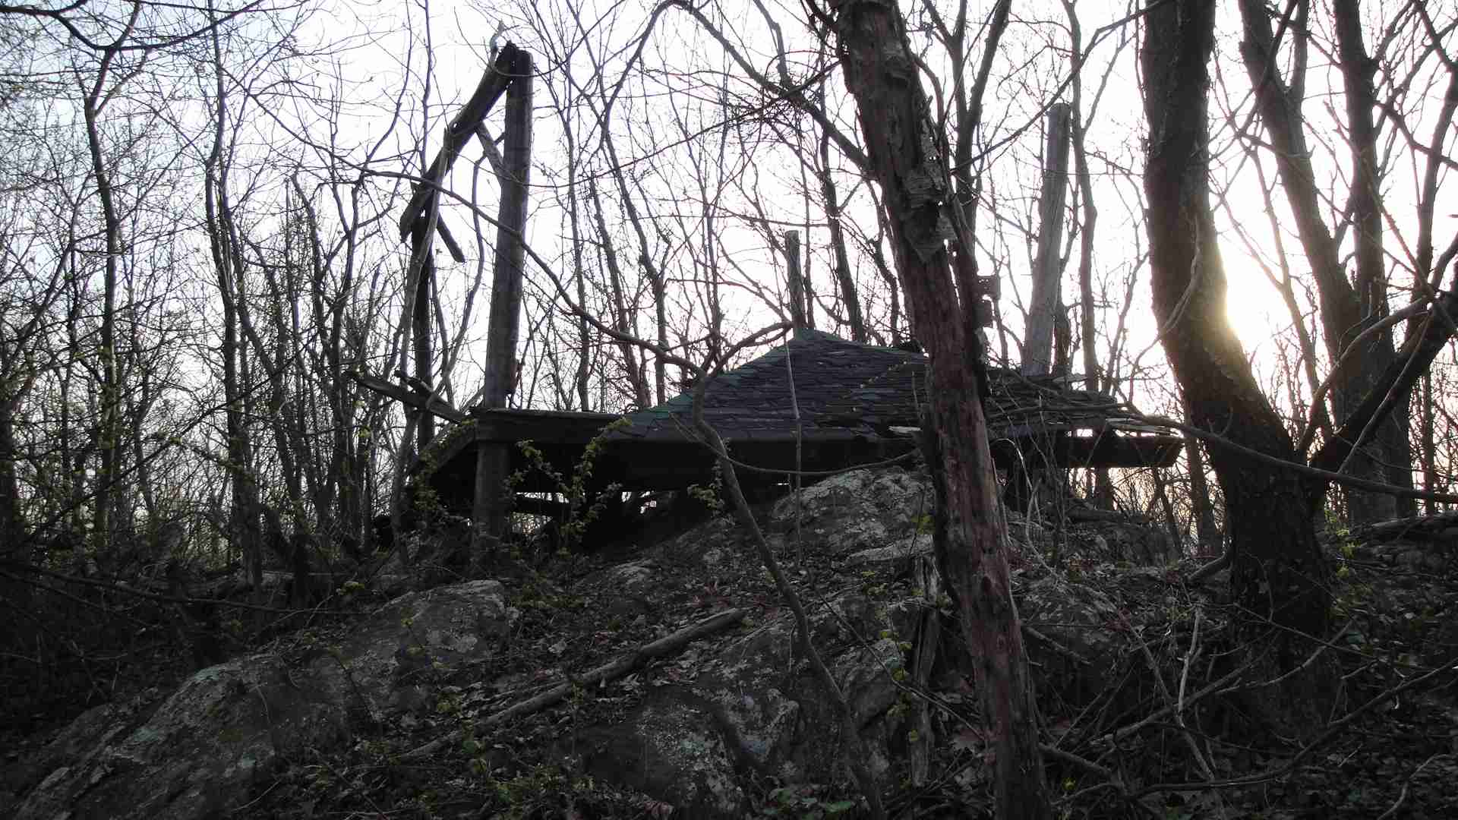
Abandoned Roof Atop Clarke County, VA HP

I drove back to the turn off to the Fauqier highpoint. Drove up the short approach road and parked near the communications tower. I walked around the loop road, and found the rock with the Warren bench mark and I was done for the day. Not bad; three new high points all in an hour and half. Now I could relax a few days and concentrate on the AT before turning my attention to the “real challenges” that awaited me in Delaware and New Jersey.
Thursday March 29, 2012 - Point Reno,, District of Columbia, 409 feet I had visited Point Reno back in 1995 well before the highpoint monument was dedicated. I had then visited the highest manmade point near the fenced area on top, not realizing the “natural highpoint” was on lower ground to the east.
I drove in from Front Royal after completing my last AT hike of this week long trip that featured great spring time weather and beautiful wildflower displays. I made my way into the District of Columbia making my way past stalled traffic on the Beltway and across the Chain Bridge into the gathering dusk. I was in a race against time again to reach the highpoint with just enough time to find the survey marker. I made my way up Nebraska Avenue past the Tenleytown Circle. Thankfully, I made the right decision to come in by car instead of taking the Metro as I would have not reached here till after dark. I soon recognized Point Reno and parked on Cumberland Street which adjoins Nebraska Avenue and is directly across Nebraska Avenue from Point Reno. I made my way up to the crosswalk and crossed Nebraska Avenue. I entered the grounds and climbed the eastern hill and wandered around a bit. I was unable to find the survey marker at first and dropped down to the gravel path between the lower eastern natural area and the artificial higher area to the west. I started looking frantically about and was starting to climb the artificial western hill before I pulled out the trip reports and realized in time it couldn’t be here. In the last light of day I resolutely climbed back the eastern hill and in the last fading light as I walked through the grass and spotted the Point Reno geodetic marker. Hurrah! I found it!
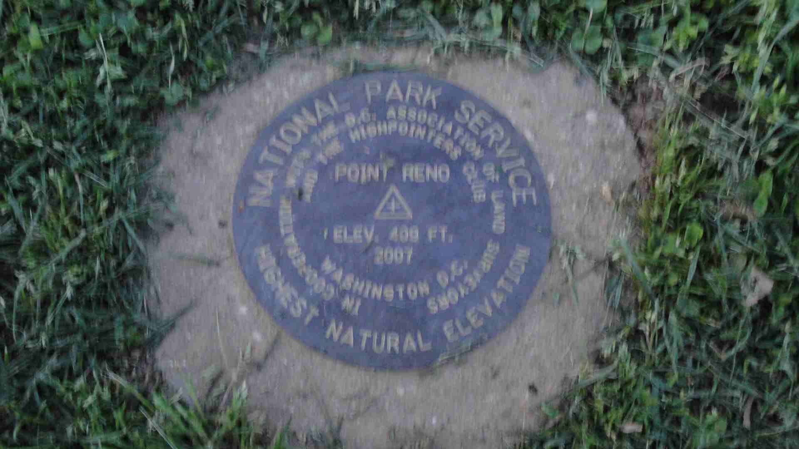
District of Columbia Highpoint Point Reno el 409 ft

I looked for a decent place to eat as I left the District on Connecticut Avenue. A friend recommended a good Jewish delicatessen. Unfortunately, it was late and not near Point Reno or where I was headed. Finding nothing decent I drove the Capital Beltway and US 50 east to Annapolis where I stopped at a so-so diner before driving across the Bay Bridge. I was really tired from lack of sleep and had to stop several times to keep myself from falling asleep at the wheel. I finally arrived at my hotel the Mainstay Suites on the outskirts of Dover, Delaware at midnight.
Friday March 30, 2012-Kent #211, and Sussex County #214, Delaware Highpoints + Talbot #212 and Dorchester County, MD #213
I slept fitfully through the night. I dreaded the next two days coming up with various scenarios of irate landowners confronting me about trespassing on their land facing possible arrest and having to reveal my crazy hobby to my family. Doubts ran through my mind. Do I really want to take these risks to wander through farm fields facing arrest or worse even getting shot? Has any one here had those doubts before setting out.
I thought of all the property owners I would have to speak with. I would have to visit 21 points in Kent County, DE alone! The next day wouldn’t be much better. I’d have to visit 12 points in Cumberland County, NJ and 10 points in Salem County, NJ plus three areas in the piney woods of Cape May County. True I had all day but I had a lot of ground to cover and many things could go wrong.
Anyway, the temptation of glory to go ahead and beat my chest to claim victory in Delaware and New Jersey was too great. The adulation you guys will pour on me upon reading this report was too much of an attraction to hold me back. I can hear the “oohs and the ahs right now. The silence is deafening.
I was compelled to do this, as the thought of the shade of green sweeping through Delaware and my neighboring state of New Jersey as I submitted my updated County Highpoint map to Adam was too hard to resist . An expanded glob extending from the shores of Chesapeake Bay to the alpine heights of Katahdin convinced me to overcome my fear and trepidations and just go for it! Or as they say in the Nike commercial “Just do it”!
The weather forecast for Friday March 30 was supposed to be sunny with it clouding up at the end of the day and a chance of rain overnight. It turned out the weather accelerated and was clouding up as I left the hotel on a cool, raw morning. It had been so nice earlier in the week and now the weather was turning cruddy.

I decided to tackle the “hard stuff” head on early in the day. I was off to Mt Hartley el 84 feet which according to a trip report filed by John Mitchler on June 17, 2007 may in fact be the “King of Kent” and negate the need to do the 20 other points. Oh, I so wish this was true but I know there was no hard conclusive proof that it is and as a true and faithful County Highpointer. I would have to visit all other 20 points or be booted out of this group.
So here goes. I took DE 8 and DE 44 out of Dover making my way west to Hartley. I was there in 20 minutes from my hotel. Hartley is a one stop sign town that if you blink you could miss. It is located 11 miles west of Dover on DE 44. Hartley consists of a church, a post office, an abandoned lot of used cars and some old homes in varying conditions. It did not strike me as a place I would be welcome. I knew driving around in a Prius with New York plates I would be sticking out like a sore thumb. I knew I would be doing a lot of nervous “looking over my shoulder” over these next two days.
I drove beyond Hartley by a half mile looking and found the lane to turn off to Cindy and Richard Schweiker; the family that has the alfalfa farm that Mt Hartley sits upon. As I turned up the driveway to go to the farmhouse a pickup truck coming in the opposite direction came towards me. Uh, oh! Busted already! As the car came towards me, I pulled over to let it pass. It slowed down and I knew I had to get out to explain what I was doing here. My worse fears were coming true and I hadn’t even reached the first highpoint.
I got and walked to the pickup truck. The woman questioned me and wanted to know what I was doing here. I lamely explained (I’ll be using this word ”lamely” several times in this report) I was a County Highpointer and I wanted to reach the highest point in Delaware which is reputed to be Mt Hartley located on your farm. The woman told me; “well you’ll have to speak with my husband. He’s at the farm house”. I thanked her got in my car and drove over to the farm house. I knocked on the door and a bare chested man with a white beard greeted me. I gave him the same “song and dance” he gave my wife. He wanted to know where I was from and made small talk with me for a few minutes and then said I could walk out there as long as I stayed off the alfalfa which young green sprouts were pushing up from the soil. I walked out there skirting along the edge of the field towards the wooded area at the back of the field. I took a few photos and walked back to the farm house and thanked the farmer. The farmer, Richard Schweiker and I talked some more, this time he showed me some Lenape Indian tools he had found while farming. I didn’t want to stay too much longer as I had 20 more points to visit, just to finish Kent County.
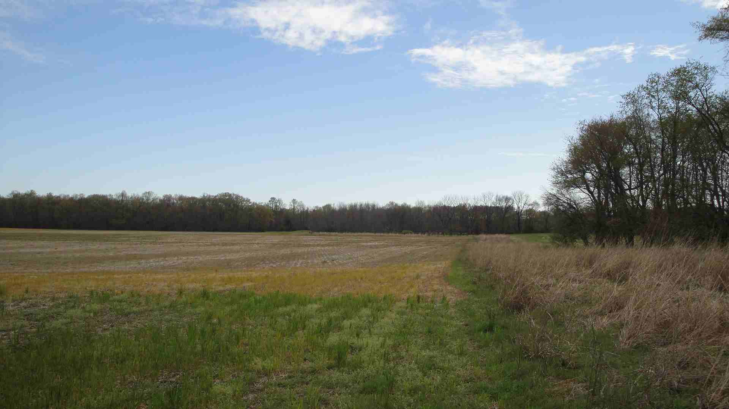
Alfalfa Field on Mt Hartley - 85 ft

The second highpoint I had to visit was just off the lane I drove in on. I stopped just short of DE 44 and walked out into a fallow field under a gray sky, not too far from another farm house. It was a “quick dash” affair another word I will be using frequently in this report. In other words, “get in and get out as fast as you can.
I drove east on DE 44 to the opposite end of Hartley and turned left on North Street which came to a dead end in a farm field. I thought of all the highpoints around here this would be an easy one to do as none of the previous trip reports indicated any issues here. I simply would walk northeast out through the field to follow a line of trees to my right to reach the first highpoint and then across another field to another line of east west trees to claim my second highpoint. As I exited my vehicle all was quiet except for a few barking dogs. I figured being it a Friday morning people would be away at work in case they were wondering what a solitary man was doing walking through a field. I grabbed my hiking pole just in case “man’s best friend” confronted me.
I walked out across the field and reached the first highpoint perhaps a football field away from where I was parked. I started out towards the second row of trees and when I was perhaps 100 feet away from the second highpoint I hear a horn blaring in back of me. To my shock I see a red and silver pick up truck racing towards me with lights flashing and horn blaring.
I had been caught! I stopped walking and turned around to face the truck. The truck looked official with something like Kent County Fire & Rescue engraved on its body. A husky middle aged man with a gray moustache exited the field and demanded what I was doing walking across these fields without permission from the landowner.
I lamely explained I belonged to a group called the Highpointers Club and that I had a rather eccentric hobby and was trying to reach the highpoints of Kent County. I said I would very much appreciate if I could just walk over to the line of trees that I pointed to just 100 feet away. The man told me next time I really should speak to the landowner which was a perhaps 200 yards distant. Since there would be no next time I said I would but since I was almost here already. Before I finished my sentence he said go ahead. I told him I’ll be right out.
Now with great relief I walked to the line of trees claimed my fourth point in Kent County and by the time I turned around to return to my car the man and his pickup truck were gone.

I nervously got back in my car as I was not quite done with Hartley yet and I felt “the eyes of Hartley” were upon me. There were two unwelcome encounters with “the locals” and the day was still young. I drove out to DE 44 not knowing if I were being followed. I drove east to the abandoned package store and wandered out into the field for Point #5.
I got back in the car and drove west looking for Crystal Road. This was the highpoint I was really worried about as Fred Lobdell reported his encounter in March 2006 with the lady at House #206 did not go well when she flatly turned down his request. As I drove back into Hartley I noticed a Delaware State Trooper had pulled over a car. Uh, oh, I was a marked man! They were looking for me. One false move and I was headed for the slammer!
I drove past the trooper driving west from Hartley. I turned around and decided to take a back door route circuitous route to Crystal Road so I would not have to parade past the trooper again with my New York plates. I felt like an “outlaw”. Busted already and heading towards this lady’s driveway who I know if I encountered her would not be giving me the “red carpet” treatment.
I resolutely stopped between #206 and #218. No one appears to be home. Finally, some good luck comes my way. I run up the dirt driveway between the two houses and reach the high ground near the back of the driveway, run back to my car, hop in and the “Hartley 6” were done. I thought great 6 points in Kent County done, only 15 more points to do! I’m on a roll!
Next destination, Seenytown! I drove north on Judith Road several miles through the Delaware farm fields to where Judith Road meets Dinah Road. I stopped at the white farm house on the right after being forewarned back in Hartley to ask permission I felt obligated to do so. I approached a man at the end of the driveway to ask permission. He told me I was not the owner but should ask the owner over there who was on a tractor mowing his lawn. I walked over to him and tried to explain who I was and what I wanted to do. The farmer was curious and suspiciously asked if I were the tax assessor. I said no, I was just looking to reach the highest points of Kent County and “I just wanted to go out in the field across the road and stand on the highpoint”. The farmer told me “go ahead”. I moved my car across the street climbed the embankment and wandered around the field a bit. I walked southwest across the fallow field crossing a dirt road and saw a fire burning near the end of the field. The area all looked pretty flat and I didn’t want to approach the fire to close for fear of having to confront another landowner to explain my doings here.

Now, was my biggest challenge of the day! I was headed to Twin Eagle Farms area where I would have no less than fourteen points to visit, on multiple parcels of property. I knew to be successful here I would have to encounter a friendly landowner who would allow me to spend some “quality time” to visit all the fourteen requisite points. This would be no “quick and dash affair”.
My first stop in Twin Eagle Farms was at 92 Jordan Drive, Point #8. I turned left off of DE 42 (Long Ridge Rd) and drove in 200 feet. I was thinking about walking over to the house and knocking on the door but I could see no one was home so I took a quick dash and walked the fence line with the pines between myself and the house. I got back in the car and as I was driving out an elderly man coming in spotted my New York plates and stopped me and demanded what I was doing here. Oh no! Here we go again!
I explained I was looking for the high point of Kent County. I don’t think he understood me. He said he had been living here for 43 years. I told him he was right for stopping me and that if it was someone I didn’t know who came through my neighborhood I would do the same. The man seemed to soften. I wished him a good day and got the heck out of there!
Well not very far. I turned left on DE 44, pulled over and ran up an embankment for Kent Point #9 then I ran across to the south side of the road to nab Point #10. I drove south on DE 42 for 200 yards and turned left on Deer Antler Road and climbed two more road side embankments to reach Kent Points #11 and #12. Badah bing! Badah boing! That was easy. Only thing it was beginning to drizzle by now.
Now on to the big kahuna! I do these next 9 and I can proclaim myself the “King of Kent”!
I drive up Deer Antler Road and left on Holletts Corner Road through this burgeoning subdivision of suburban homes interspersed with farms and open lots. I search for friendly ground, a place I could hide my Prius from suspicious eyes. Based on Spooky Mike’s report I head for 4076 Holletts Corner Road in search of Don who let Mike park in his driveway.
I pull up the driveway and park in the back. Nervously, I think would I have the same friendly reception? Does Don even still live here?
I knock on the door and a late middle aged blond hair woman answered the door. This is not Don, uh, oh!. I ask for Don and explain who I am and why I’m here and if I could leave my car in the driveway.
I am relieved to find that this is Don’s wife. Don’s wife granted me permission and I was off on my quest to walk the “9 points of Twin Eagle Farms”. I had found my “safe haven”.
Still, I was not out of the “woods yet”. Just because I was parked safely by Don’s wife I still would be wandering through various property owner’s fields. I understand Farmer Les Webb owned a lot of property to the east of Don’s property that I would be wandering through so I had another possible “life line”.
Ok so, the front yard of Don’s house is Kent #13. I then set out and walked south and east out of Don’s backyard. I walk through a line of bushes and emerge on a gravel driveway that runs east-west behind Don’s house. I walk a little east on the driveway and on the north side of the driveway behind a house screened by bushes I hit Kent #14. I continue east to where the driveway bends north to go out to Holletts Corner Road. I continue east, crossed another driveway and crawled under an electric fence to enter another field and turn right keeping woods to my right to pick up Kent #15. I continued walking south perhaps a 100 yards to the south end of the field keeping the woods to my right and at the south end of the field I pick up Kent #16. The relief is so slight here it is very difficult to distinguish the highest ground. I used a combination of Acme aerial photos and topo maps on the County Highpointers website to determine the approximate location of the highpoint, plus some wandering around the subject location. The Acme site shows the location of the highpoint through the crosshairs over the highpoint location.
Even before I left on this trip, I printed out each of the topo maps and aerial photos that I carried with me on my trip. I marked and numbered the highpoints on both the topo maps and photos to correspond with the numbers found in the previous trip reports. I carried these maps and photos on my trip and was continually studying and referring to them. The combination of trip reports, topo maps and aerial photos were vital to ensure I was “hitting” all the high points.
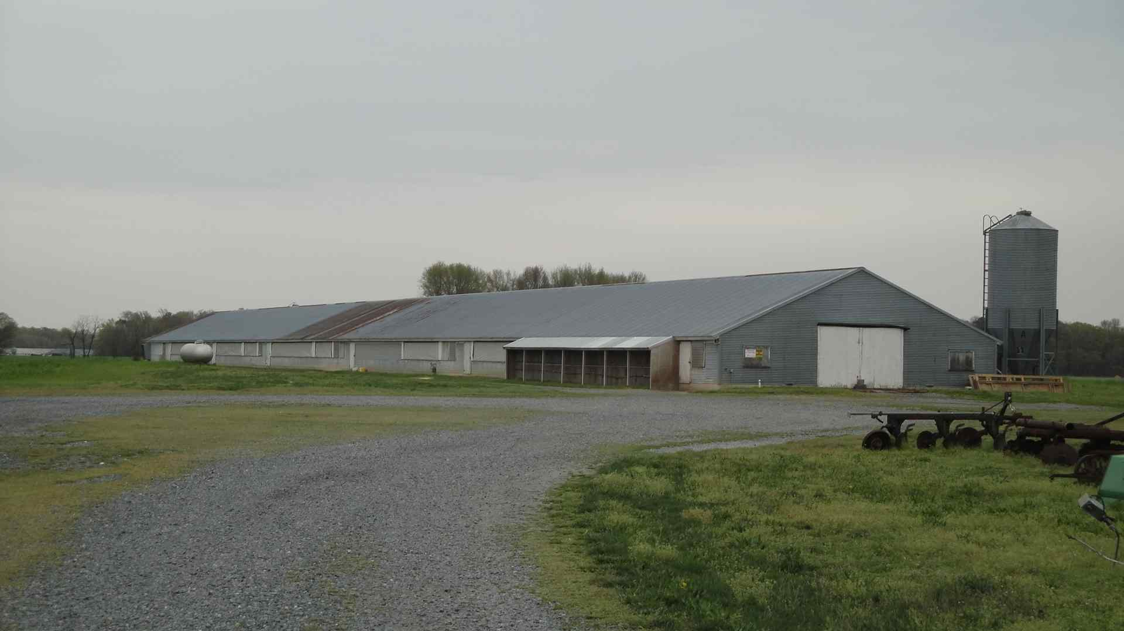
Kent County, DE Twin Eagle Farms

Reaching Kent #16 I made a left turn and going east again by crossing the field to Points #17 and 18. I then turned right going south again with woods both on my right and left and entered a wide open area with some low buildings well off to the east. I reached Point #19. As I reached Point #19 I heard a tractor in the field to the east and a yell coming from the tractor. I hightailed it out of there and made for the woods passing into another field by crawling under another electric fence and was out of sight of the tractor. I continued back north and west finagling going north between two driveways that eventually led me to Holletts Corner Road.
I walked the road west a bit in a light rain and then crossed to the north side and walked behind a house where no one appeared to be home. I walked the field behind the house for Point #20. I continued walking west northwest keeping a line of trees between me and the backyards of homes to the south. Still I felt a “sense of guilt” knowing I didn’t belong there. I reached the 21st point near a point on the field at the edge of the woods. Somehow even though I finished Kent I was not feeling a sense of elation. I still had to get back to my car. I looked for an exit to Holletts Corner Road. I heard someone mowing their lawn on their tractor as I passed the backyards of two homes so steered clear. I finally was able to skirt around a home and entered Holletts Corner Road.
As I walked Holletts Corner Road back to Don’s house an elderly woman approached me and wanted to know what I was doing walking behind the homes. I mumbled something that I was looking for the high points of Kent County and then walked quickly down the road to Don’s house. She did not pursue me. I reached my car and quickly drove away. My emotions were mixed on this dreary day. On one hand I was relieved and pleased to reach the highpoints on the other hand I was tired, shaken with my encounters with the land owners. I was glad it was done and would be able to “check off” another county on my growing list.
Though Kent County was done, the day was far from over. I still had Sussex County, DE to do to complete Delaware (New Castle County, DE) where the state highpoint of Delaware is located that I had done years ago and on multiple visits.
My ambitions were big that day. Not only was I planning to finish Delaware. I decided to squeeze in some easy Maryland County highpoints; easy being defined as one to three points and being right off a road.
The time was 1 pm as I left Kent County, DE and crossed into Maryland. I stopped briefly at a rest area on US 301 to have a quick snack and headed south on US 50 to Easton, MD. I was hungry having not eaten since 7 am when I had a quick continental breakfast in the motel lobby. Many fast food places tempted me as I drove by Easton but I knew time was short as I had to make a 7:45 pm ferry at Lewes, DE to Cape May, NJ. Any delay could sacrifice reaching highpoints or missing the ferry schedule that would ruin my next day plan’s to complete New Jersey. I was expected home by Saturday evening, so if I missed the ferry I would get a late start the next day making it impossible to complete New Jersey.
Time was the essence and had to be used as efficiently as possible. Sussex County, DE had the priority but if I though I could squeeze a couple of COHP’s in Maryland “to rack up my COHP totals” and get you all wowing, why not! As Gordon Gecko once said; “Greed is good!”

I turned left on MD 331 (Dover Bridge Road), drove south 1.4 miles and left on Barkers Landing Road for 0.2 miles. I parked on the side of the road saw the landfill (artificial ground) off to the left and I was headed off to the woods to the right for perhaps a 100 yards to a natural rise overlooking a an old railroad cut below.
Back to the car and off to Dorchester County, MD the site of a Perdue chicken farm. I followed MD 331 through Preston and turned off onto MD 318 and looked for the sign for “Lowry Farms”. I turned right and drove up the driveway to the house. I could see the chicken shed where the highpoint was some 100 yards southeast of the farmhouse. I knocked on the door of the farmhouse several times and received no response.
Assuming no one was home I walked down the dirt road to the chicken shed. I walked the length of the shed to its far end where the highest ground was located though honestly it all looked flat to me and added Dorchester to my notch of now #213 COHPs.
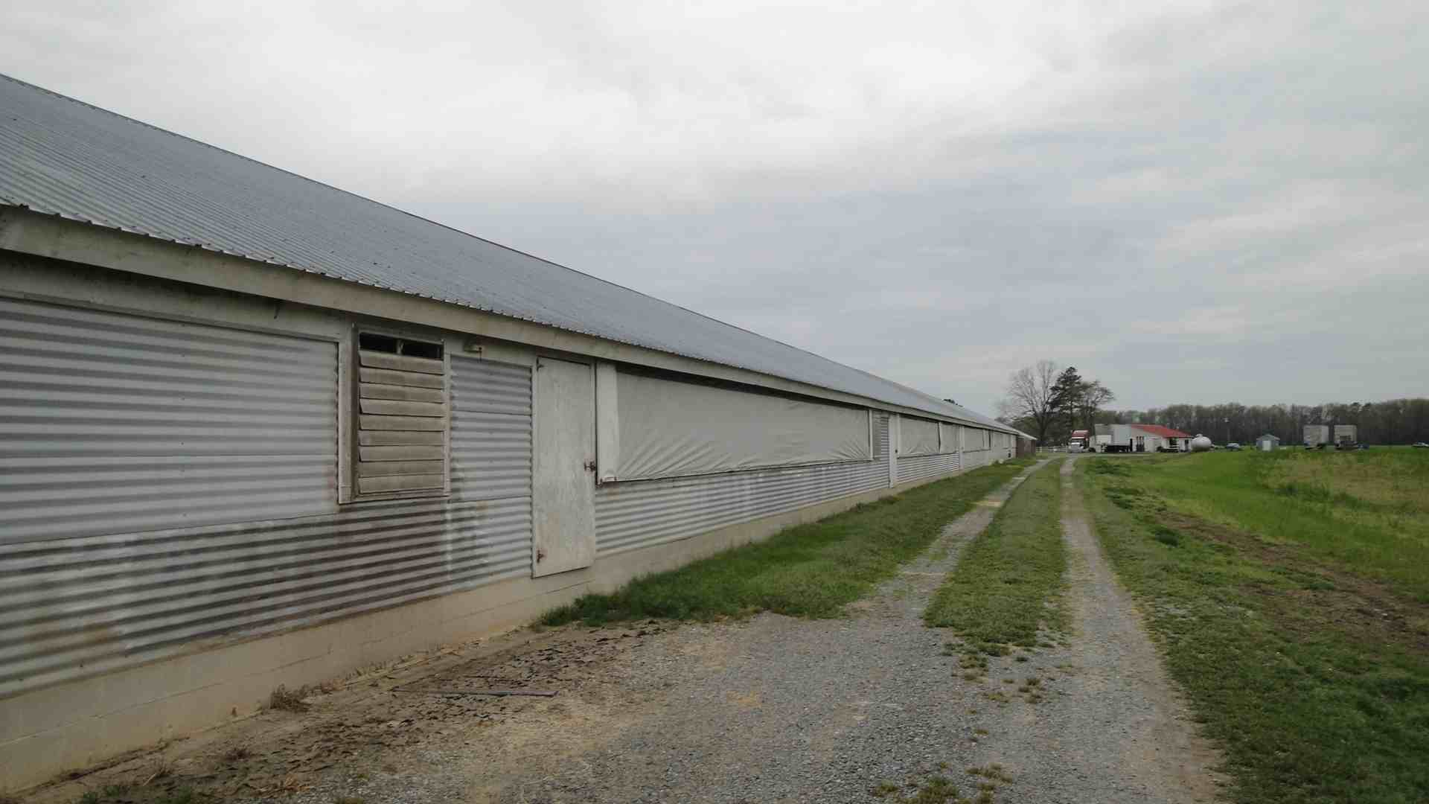
Lowry Chicken Farm Straddles Dorchester County, MD HP

As I drove out of the driveway of Lowry Farms a pickup approached me with a man behind the wheel. This was another uh oh moment! The man passed my car paying me no heed.
I looked at my watch and decided to scrap Somerset and Wicomico Counties, MD for another time. It was well after 3 pm and it was time to tackle Sussex County, DE before heading to the ferry.
I made my way south and east to reach US 13 in Delaware near Laurel, DE and then turned off on Whitesville Road (DE 30) and drove this back road east. I overshot the turn off to Whitesville but was able to find DE 54 which took me back to Whitesville.
There are three highpoints in Sussex County, all located fairly close to Whitesville and a fourth highpoint, though reputed to be artificial on a sand dune in Cape Henlopen State Park that I would visit last.

I drove to the western most highpoint of Sussex County highpoint, 1 area 1 ¾ miles west of Whitesville which is located in a forested game preserve along DE 54 which straddles the Maryland/Delaware border. I drove past the highpoint and turned around at Melson Church Road that leads south into Maryland. I drove back east for 0.7 miles and parked on the eastbound shoulder (Maryland) opposite a gated dirt road leading north into the game preserve. I went into the woods bushwacked around for several minutes and headed back to my car.
I drove east passing and taking note of the State Line Ranch on my left. I passed the dirt Cadd Road and then reached Whaleys Road and turned left. I went north on Whaleys Road for about a ¼ mile and turned left on dirt Cadd Road which I followed west for 500 feet passing a few trailers. I parked at the westernmost trailer, got out and knocked on the door.
This was really an out of the way, “red neck” place in the woods. The trailers looked quite ramshackle. I had doubts about coming here not quite knowing what type of reception I would receive. A young woman answered the door and I told her I was a County Highpointer and wanted permission to walk out to the field to visit the highest point in Sussex County. The woman told me she did not own this property but that the owner lived in the easternmost trailer across the way that I had passed and I would have to ask him.
I sheepishly walked over to the trailer realizing it all came down to this. If I was denied I would be unable to complete Sussex County, DE and all of Delaware for that matter. The ordeal I went through earlier in the day would be for naught.
Luck was on my side! I knocked on the door and a disheveled man opened the door. He looked none too pleased to see me. However, when I told him what I was doing he said “go ahead”. I took that as a green light thanked him and was on my mission to complete Delaware. There were two points I had to visit. I walked the field west of the trailer to a slight rise for the first area. The second area was on the State Line Ranch that I observed driving over on DE 54. The State Line Ranch is a horse farm. I was able to reach it by cutting through a few woods and open fields. The woods in this area were full of brambles with their sharp thorns which made passage difficult.
At the end of one field I found a dirt road that led west that made passage somewhat easier, so I thought. Then I saw another trailer with smoke coming out which indicated someone could be there. I headed back into the woods and skirted to the north staying well away of the trailer. I finally emerged on to an open area with a view of the horse pastures and a barbed wire fence between me and the pastures. I felt I had emerged on to the highest ground of whatever could be distinguished as high ground and headed back to my car checking myself over for ticks. Fortunately, there were none.
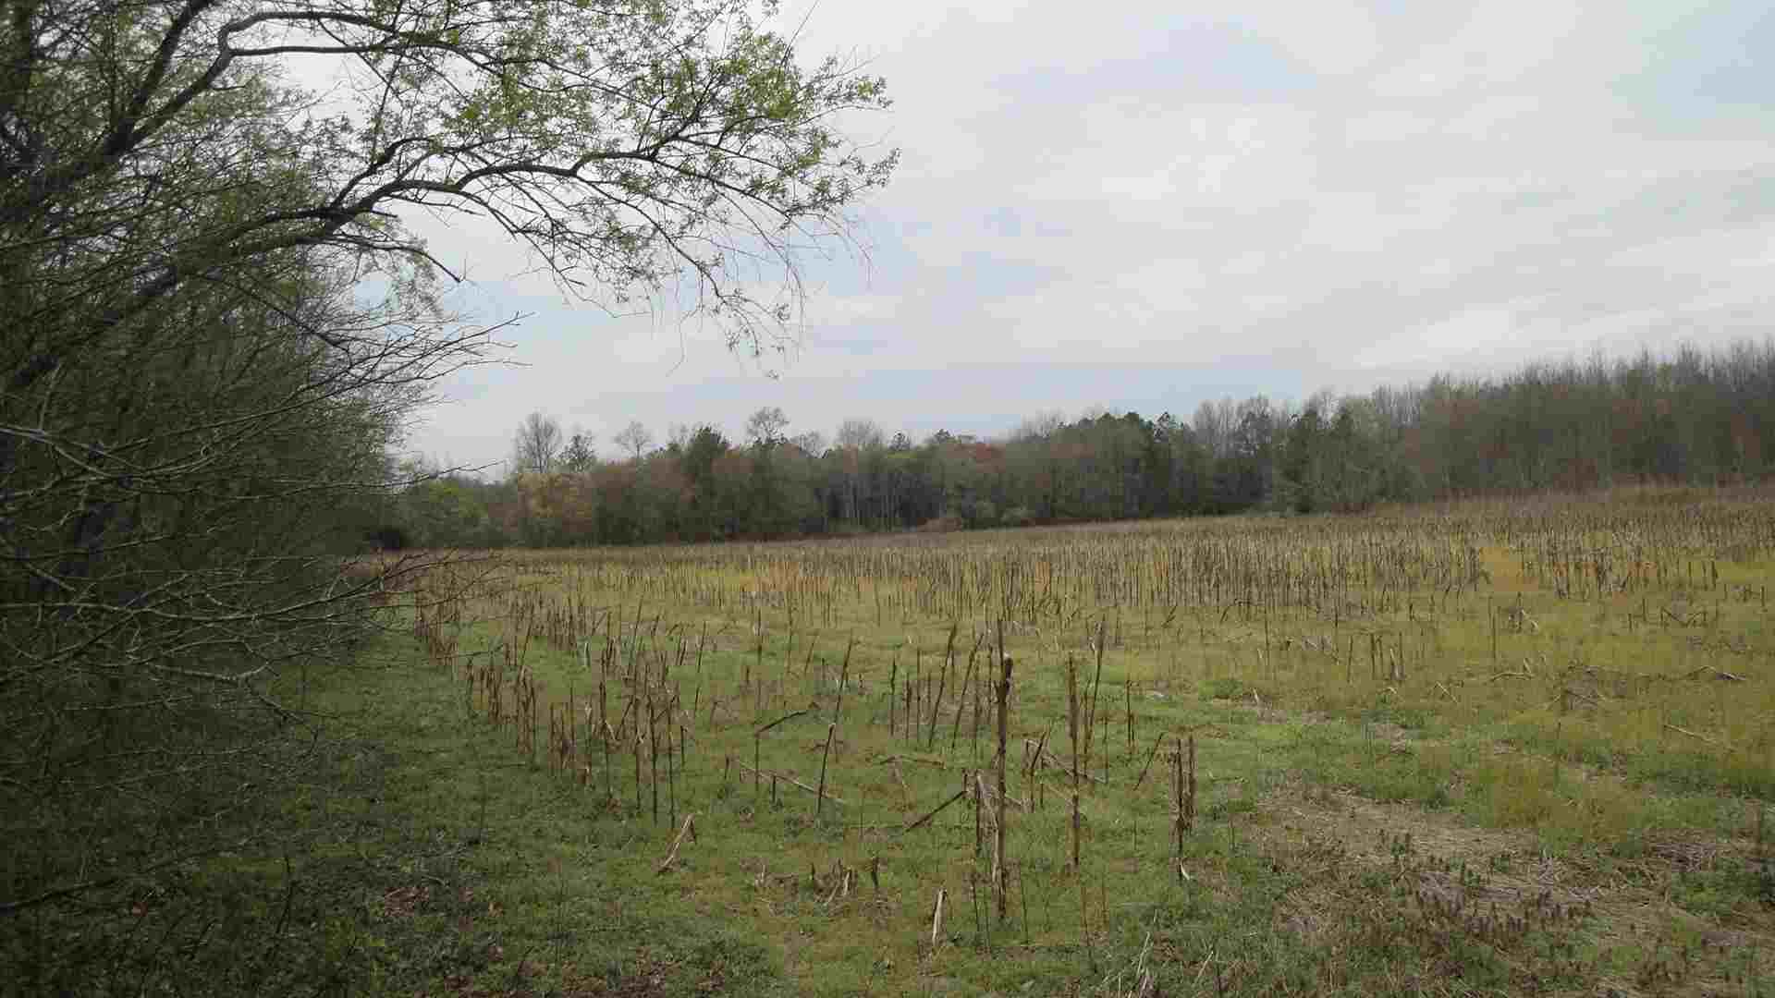
Field Behind Trailers-Whitesboro, DE

The last highpoint of the day in Cape Henlopen State Park was a fun one, a scenic one and one on “public land”. Hallelujah! My only challenge was finding it and making it to the ferry before it sailed. It was getting on towards 6 pm by the time I finished “the red neck highpoints” in southern Sussex.
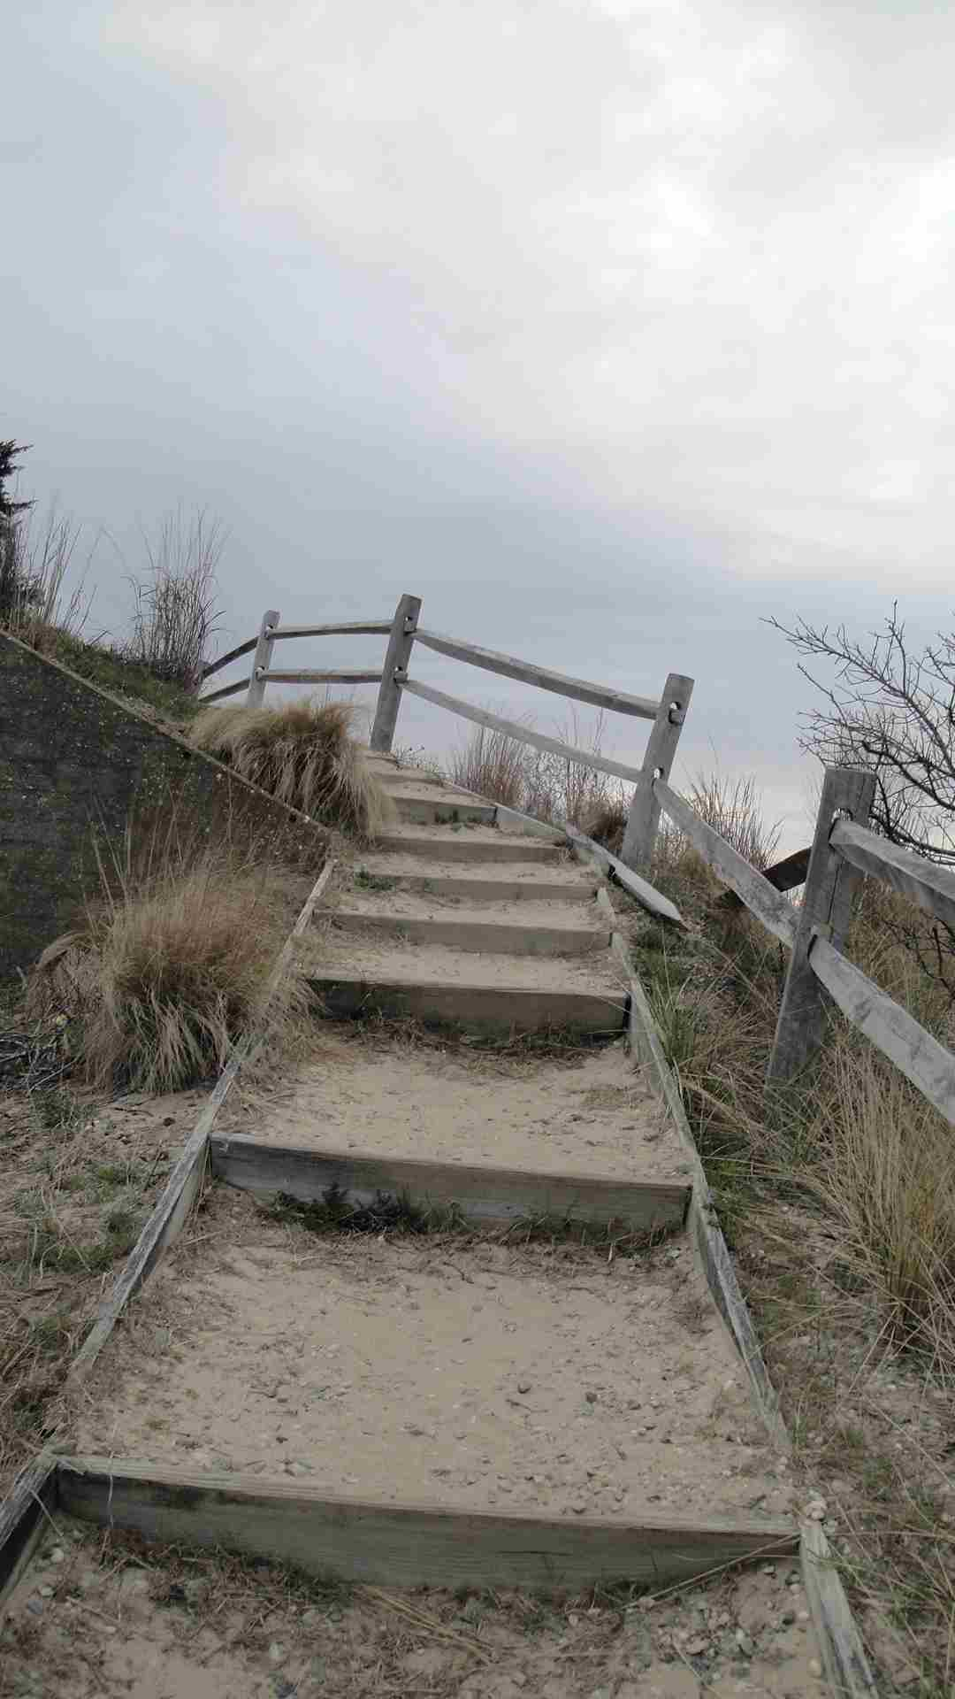
This is As Vertical As it Gets in Delaware! Cape Henlopen State Park

I followed DE 54 then DE 30 to Millsboro, DE then DE 24 to US 9 and to the final approach to the Cape May ferry. It was about 6:45 pm as I passed the Cape May ferry parking area and headed into Cape Henlopen State Park. I could see the sand dunes rising in the distance with a chilly mist rising from them. One advantage of coming so late in the day was I avoided the $8 parking fee as no attendant was at the park gate to collect.
I drove deep into the park and found a parking area. I parked first near an observation tower and then moved my car near another parking area close to some Quonset huts. I emerged from my car and a chilly breeze was blowing off the Atlantic Ocean. As I walked the sandy path towards the dunes I could look out on the forlorn beaches with breakers coming in the waning light of day.

I saw bunkers and big guns as this military installation protected our shores during the First and Second World War. I climbed up steps leading to the top of the sand dunes and then walked on top finally feeling exhilarated. I had finally done it! DELAWARE WAS MINE! What a glorious place to complete “The First State”. What if Sussex’s true highpoint was at Cape Henlopen, instead of the misery that waited in the brambly woods further west. If only Mt Hartley could have been verified to have been the Kent County HP instead of having to visit all those other 20 points. If only!
I arrived at the ferry bought my ticket and arrived there with 20 minutes to spare!
I could finally relax and blend in as a “normal guy” with the other “travelers”. The journey across to Cape May cost $33 for passenger and driver. The journey was uneventful. It was rather cold and raw outside with a northeast breeze coming right off the chilly waters of the Atlantic. I was looking forward to a meal on the boat en route but the prices were outrageous, the choices were limited and the food quality was awful.
Picture paying $3.00 for a frozen hot dog to microwave into a soggy, rubbery hot dog loaded with by products. No, I passed on this awful stuff and headed to the first Mc Donalds on the New Jersey side, though there I had to tell the “dense” server six times I did not want ketchup or mayo on my hamburger till he got it right. I ate a dried out hamburger, warmed over french fries and a Sprite which served as my dinner at 9:30 pm. I filled up on “cheap” Jersey gas at $3.79 a gallon. I still had a 40 mile drive to the Fairfield Inn in Atlantic City.
I drove bleary eyed up the Garden State Parkway, yawning much of the time, rolling down the window at times and playing the radio just to stay a wake. As luck would have it I missed my exit and drove ten miles out of my way before I could turn around.
I had one of the hotel coupons I picked up at a service area which gave me a room at the Fairfield Inn for $74 a night. Now with that stay and a stay of three nights a few days earlier at that I stayed at to hike the Appalachian Trail in northern Virginia I earned five free nights at the Marriott Hotel chain when signing up for the Marriott Rewards credit card and with one purchase on the card. What a deal!

Saturday March 31, 2012 – Cape May County #215, Cumberland County #216 and Salem County, NJ #217
I woke up at 6 am Saturday morning still not refreshed. I had another challenging day ahead of me. First drive south into Cape May County and take a walk in the piney woods to pick up the three areas there, then it’s on the South Jersey farm country of Cumberland and Salem Counties where I would have to visit 12 and 10 points respectively followed by a three and a half hour drive home to Long Island. Ugh!
Actually, normally, I would have been enthused to do this but my fatigue, days on the road and traversing on private land which I just normally eschew but I’m making the exception this time because this is what I needed to do to finish up to “green “ these two states.
I drove south into the pinelands on a gray, dreary morning with my energy running “on vapors”. I followed US 40 west and then NJ 50 south to Corbin City, then right on NJ 49 and then the left fork on to Cape May County 548. The first stop was off of Cape May County 548. I drove west through the pinelands on a flat road that bored west through the forest straight as an arrow. As I passed by some overhead powerlines I knew I was getting near. I spotted a dirt road coming up and turned right. The dirt road appears on topo maps as Hunters Mill Road. I drove 0.9 miles to the power line crossing and then followed the power line perhaps 100 feet southeast to the highpoint.
I returned to Cape May County 548 and drove east, turned around at the powerline and drove 0.5 miles west. I followed the dirt road in going northwest. I followed the woods road as far as the dirt road I traveled earlier to reach the powerline and turned around and headed back just to make sure I had covered all the ground I needed to cover before plunging through the brush off to the east of the dirt path in search of the slightly higher ground that I was able to ascertain. I reached the road just east of my car.
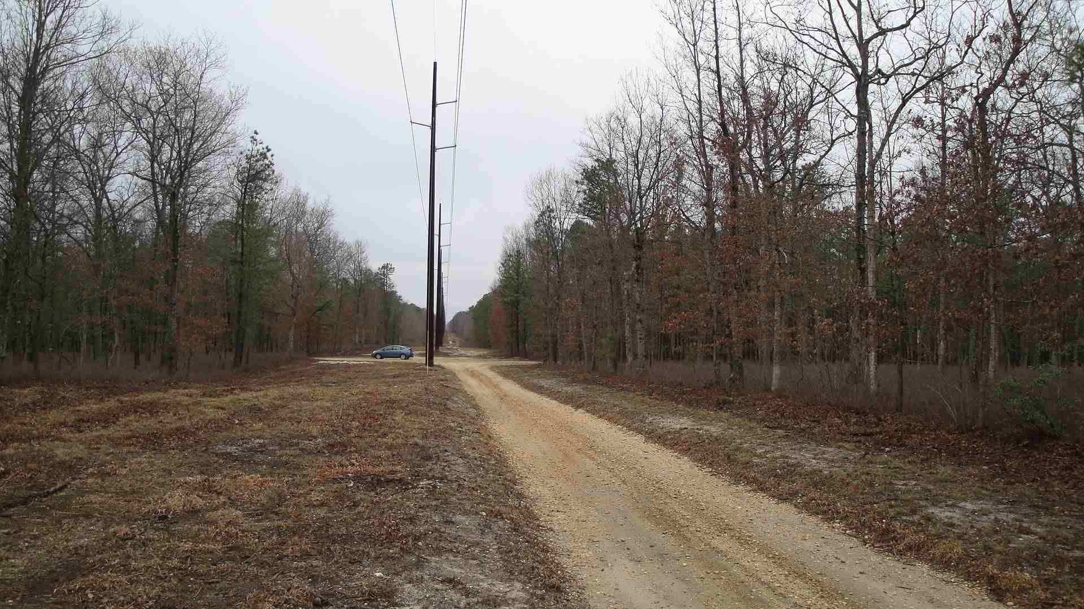
The Sand Roads of Cape May County, NJ el 60 ft!

I moved my car a little further west and to the south side of the road in pursuit of the third Cape May County highpoint, which is only 60 feet above sea level, making this my lowest County highpoint to date, even lower than Delaware. I followed the wide dirt path south until it began turning sharply to the east. I then turned southwest and pushed again through the brush and isolated clumps of laurel to what seemed to be the highest ground in the area.
One county down, two more to go! I resumed my COHP marathon. Next destination, Cumberland County with 12 highpoints. After the 21 points in Kent County, DE yesterday this should be a piece of cake.
Cumberland County, NJ is actually a more friendly environment than Kent County, DE because the highpoint areas of Cumberland tend to be more rural; meaning there is a larger space between Kent County, DE had farmland with suburban dwellings mixed in. Cumberland for the most part was rural and the inhabitants appeared to be more laid back but still it had its challenges.
Tired, I stopped at a Dunkin Donuts on NJ 49 on the east side of Bridgton. I studied my topo map carefully. It was after 11 am with the day getting on before I reached the landfill 1 ¾ mile east of Seabrook. I drove north on busy NJ 77 towards Seabrook bearing right on to Old Burlington Road and right on to Fox Road. A car was following me as I traveled on Fox Road which forced me to drive by the landfill. After driving to the east end of Fox Road I turned around and headed back to the landfill. This time the coast was clear and I turned left on the access road into the landfill. I drove up the landfill access road with the posted signs, stopped my car for 30 seconds, did a quick touch and go and I was out of there!
I next drove to #49 Weber Road and did another touch and go.
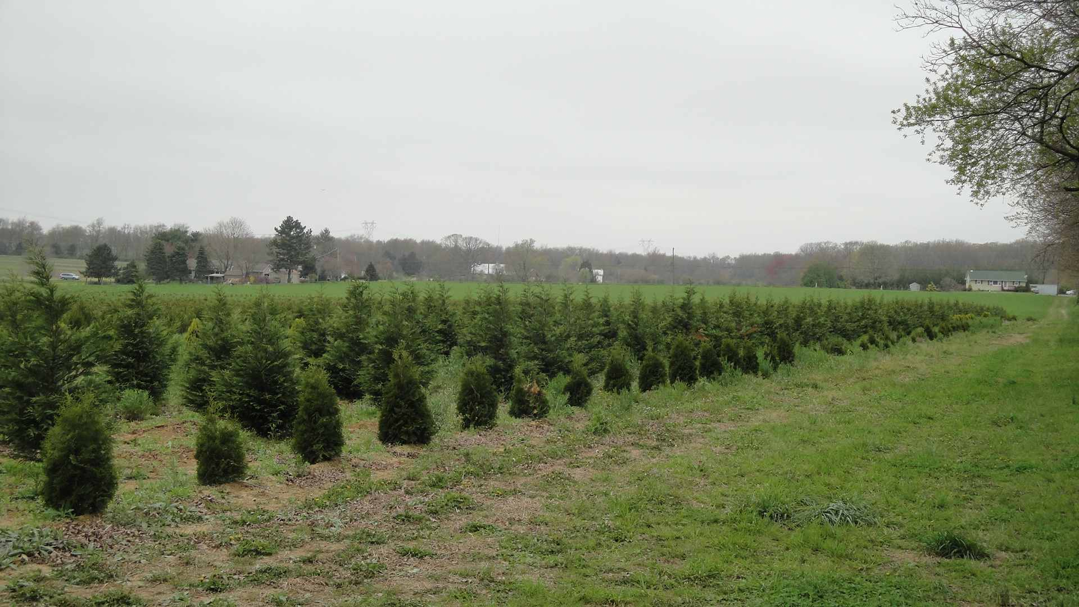
Next Year's Christmas Trees

The next three area 2 miles southwest of Beal Mills would be more challenging. I drove CR 540 west for three miles and turned left on Harmon-Cohansey Road. I drove past Harmon-Cohansey Road and drove up a dirt road and encountered some Hispanic laborers on a truck. I immediately turned around and headed back to the main road, none the worse.
There were few places to pull over and there were enough houses around to raise suspicion. What are the neighbors going to think about a blue Prius with New York plates parked along the side of the road with some guy wandering around the open fields?
I wasn’t willing to take that risk as I knew I would be here at least a half hour. So I looked pulled into a driveway for a nursery and saw a bunch of Hispanic laborers whose immigration status is of unknown origin. I walked up to what looked like the head guy to ask permission to park and wander the fields searching for the highpoints. The head guy nodded and seemed to indicate it was ok for me to wander around. I thanked him and immediately set off on my walk.
The day was cool and windy and the sky was mostly cloudy. I walked through a slightly rolling field of low shrubs with plastic vinyl sheets covering the ground. Unlike in Kent County, the previous day Cumberland had enough relief that it was somewhat easier to make out the higher ground. I walked up slope as I walked northeast towards a line of trees towards the two areas of high ground. It took me about ten minutes to reach the high ground and I could hear the laborers off in the distance who I had passed earlier in my car. I saw rows of small Christmas trees growing by the high point areas.
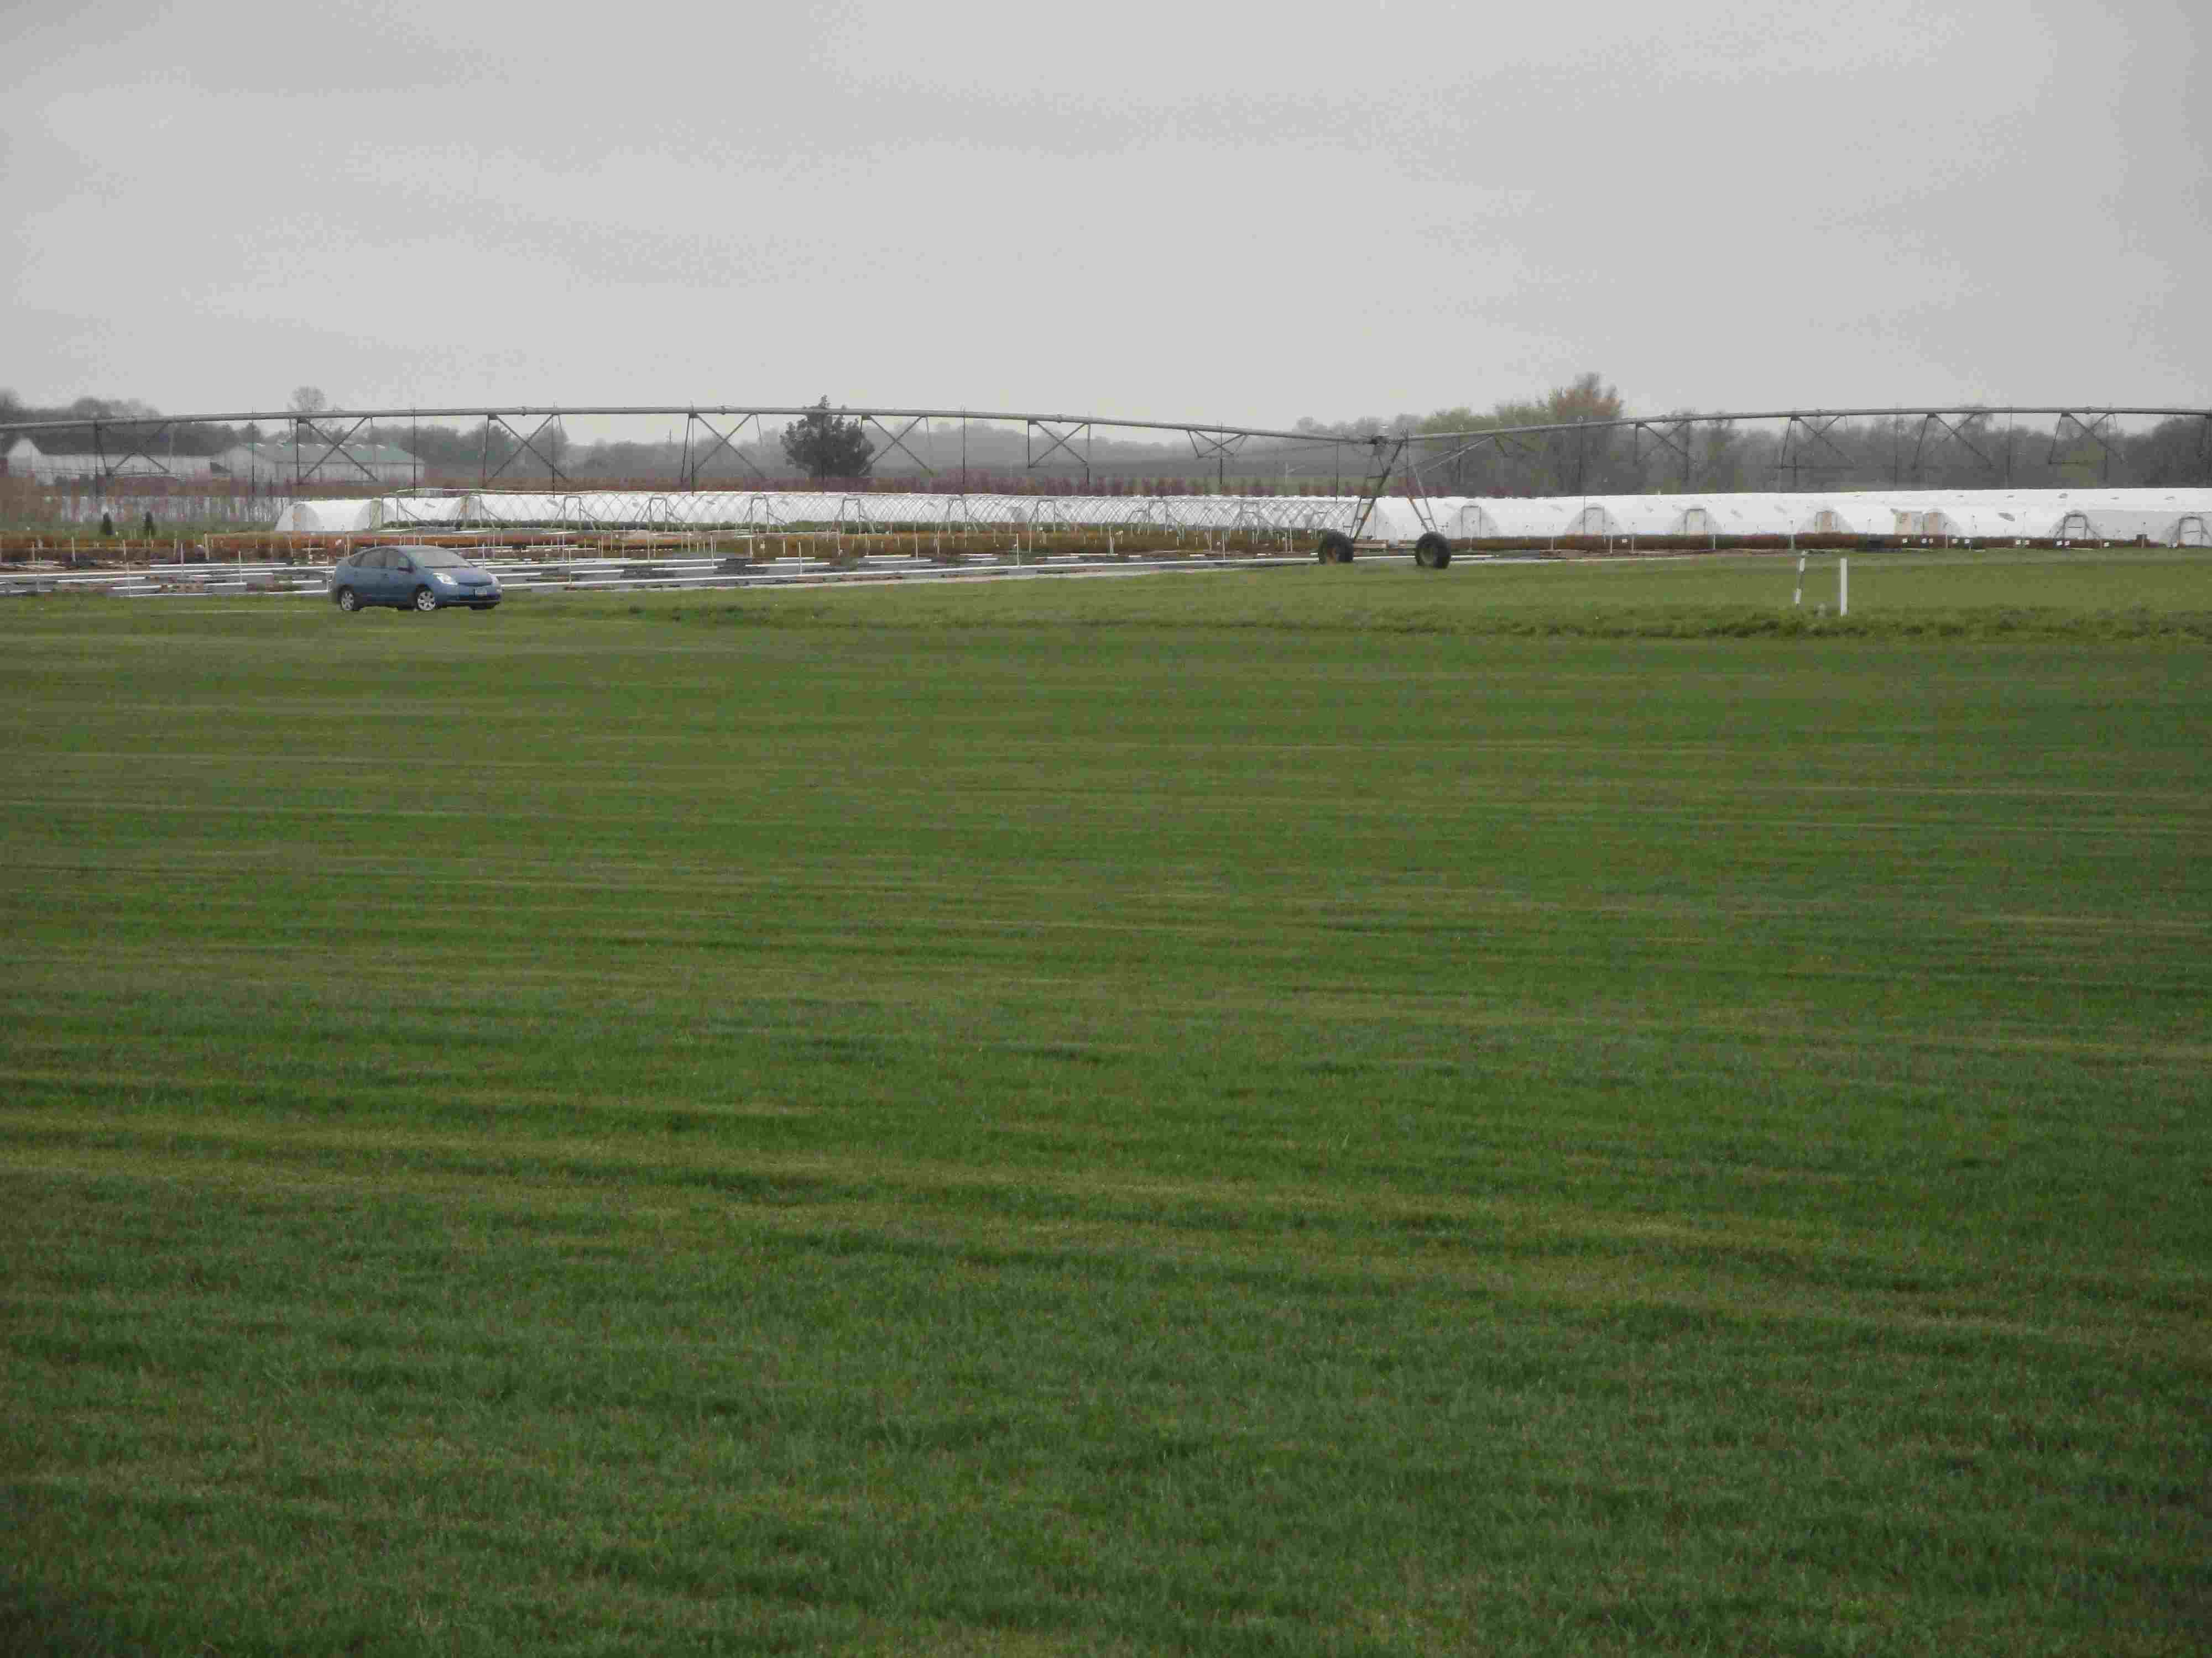
Cumberland County Sod Farm,
One of the Cumberland 7"

I then walked back to Harmon-Cohansey Road and crossed the road following the row of evergreens to the two bird houses. I walked back to my cars waved to the laborers and I was off. All I can say is muchas gracias!
My next and biggest challenge of the day was the “Cumberland Seven”. I drove east on CR 540 to NJ 77 turned left and headed north. I passed another nursery on my right and then turned right on Griers Lane. One of the high areas north of Griers Lane was fairly close to a white house, plus I thought the land owner might be able to grant me permission to wander the fields on the south side of Griers Lane. A woman answered the door and granted me permission to visit the highpoint in the field next to her home. She told me for the areas south of Griers Lane I would have to go back to the nursery I passed on NJ 77 and ask over there.
I walked out into the field to the west of her house and visited the high area near some irrigation equipment. Then I drove east along Griers Lane another quarter mile next to another smaller house where no one was home when I knocked so I visited the eastern area.
The remaining five areas south of Griers Lane covered a fairly wide expanse which could cost me well over an hour and I still had 10 points in Salem County before I could declare New Jersey “green”. I drove back to the nursery and knocked on the door. No one was there. I walked about a bit looking for someone to ask but found no one.

I wandered through the rows of Christmas trees to the north of the nursery building, just to the east of NJ 77 and covered the high ground. As for the remaining four areas I drove back to Griers Lane and drove back to the white farm house I visited area. I turned down a dirt road, opposite the farmhouse and drove it south out into the sod farm. I wandered around for 15 minutes covering all four areas. I looked for slight rises in the terrain t and headed for the top of each rise to cover the high ground. I had an uncomfortable feeling walking around on the sod as if the owner came by and saw me he would not be pleased.
I got back in my car turned left on Griers Lane and right on NJ 77 and Cumberland County was done!
Only Salem now! My first two high points were in a peach orchard. These are the two areas four miles west of Elmer. I drove NJ 77 – Pole Tavern Road and saw Colson Road, a secondary roads branching off to the left. I turned left on Colson Road and followed it to a slight rise in the road till I reached overhead power lines. I climbed the embankment and walked to the highest ground under the power lines.
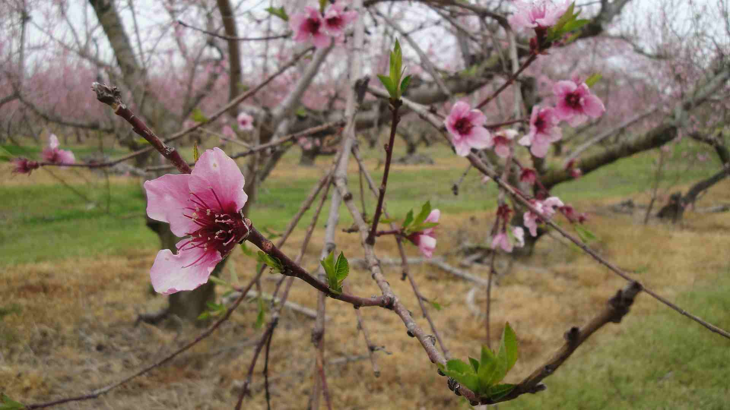
Salem County Peach Orchard

I then drove around to the NJ 77 side (east side) of the peach orchard and parked opposite the abandoned stucco house. I once again walked through rows of peach trees covering enough areas to claim the highest ground.
The next stop was the three areas two miles west of Elmer. I stopped briefly at the Wawa store on US 40 at NJ 77 for a snack before heading over there. I parked at Stella Farms crossed over US 40 and walked through the soybean field keeping the gravel pit to the right. As I was 100 feet in from the road I noticed someone had driven up to where my car was parked checking my car out. There was another moment of worry. I ignored it and continued on circling around the northern, eastern and southern areas of the gravel pit to ensure I covered all the high ground. By the time I returned to my car the man was gone.

I was off to the intersection of CR 619 Woodstown-Whig Lane Road. I stopped my car by a barn with some cows. My sense of caution was dropping as I just wanted to get this done so I didn’t bother stopping at the house on the other side of the road to ask permission to walk the field. I walked well out into the field with a cold, gusty wind blowing to cover the two high areas. It took me about ten minutes to walk around the field till I was satisfied before returning to my car. No worries.
I drove north and west to 305 Whig Lane where a stately brick house fronted the north side of Whig Lane. I turned left on a dirt road as I approached the brick house and drove south about 100 yards to the highest ground before turning around. I exited my car snapped a few photos and headed out to my final stop of the day.
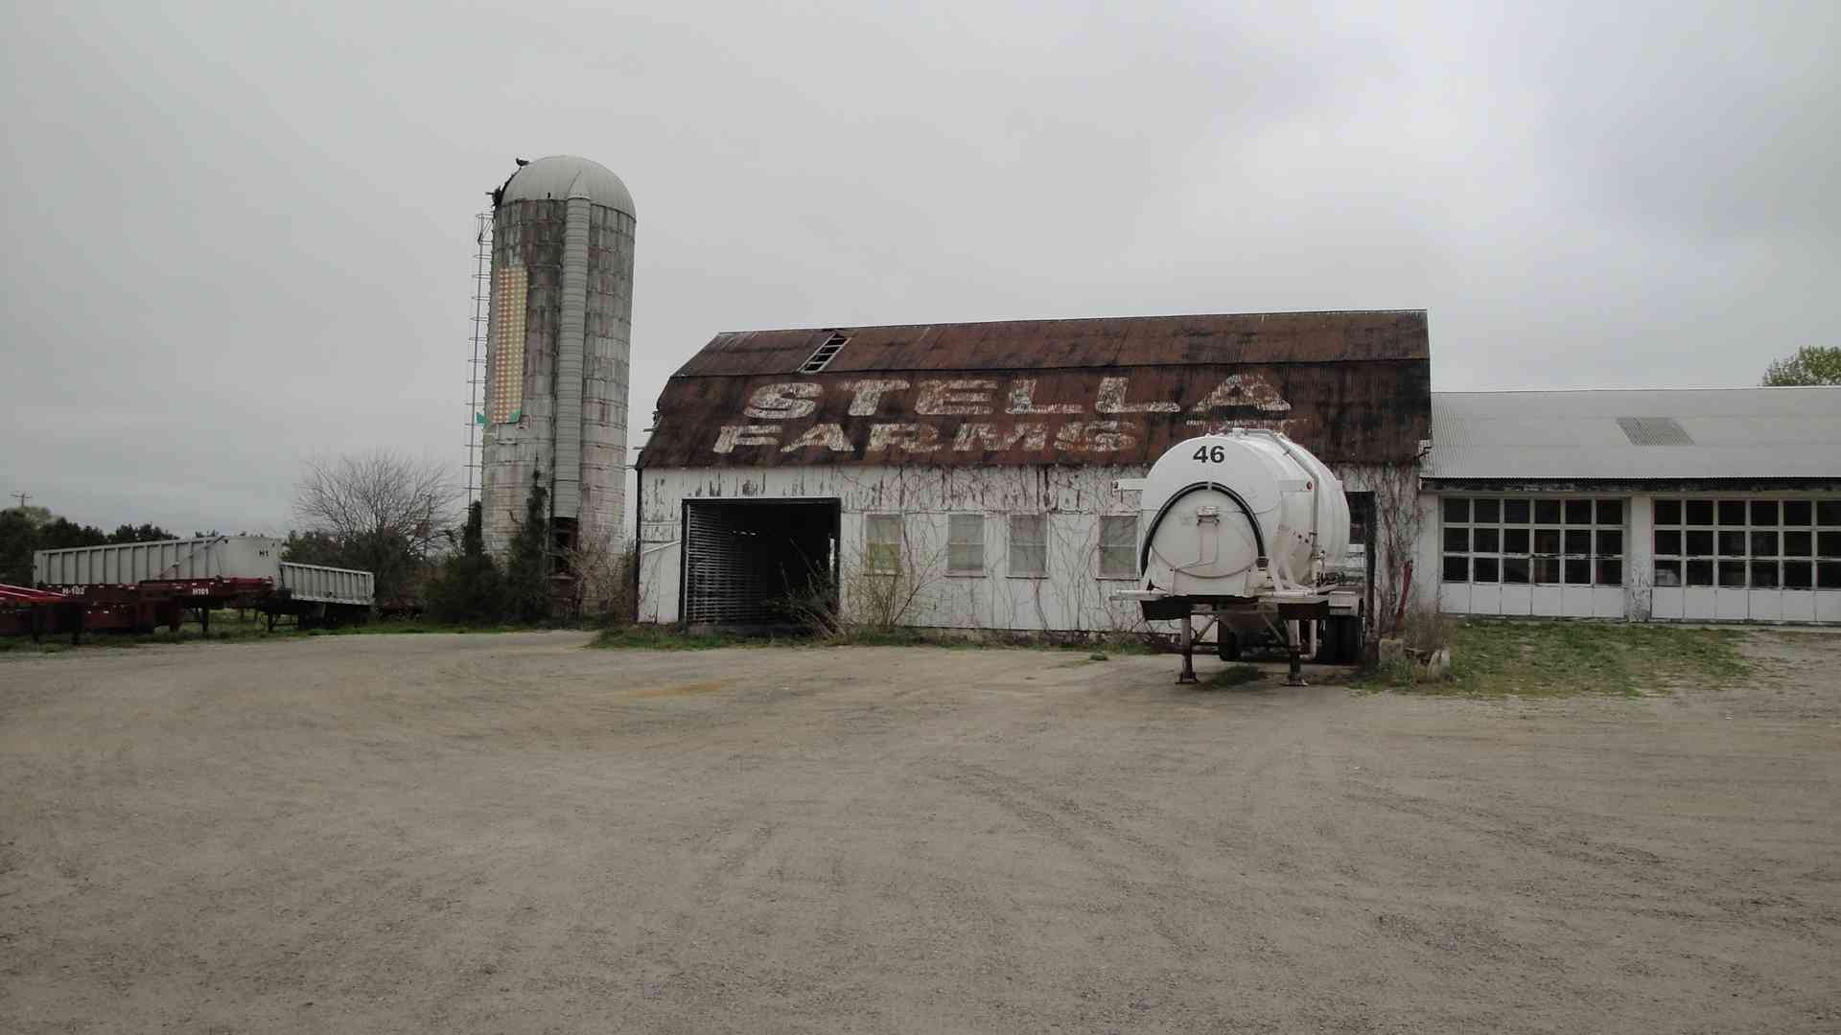
Stella Farms

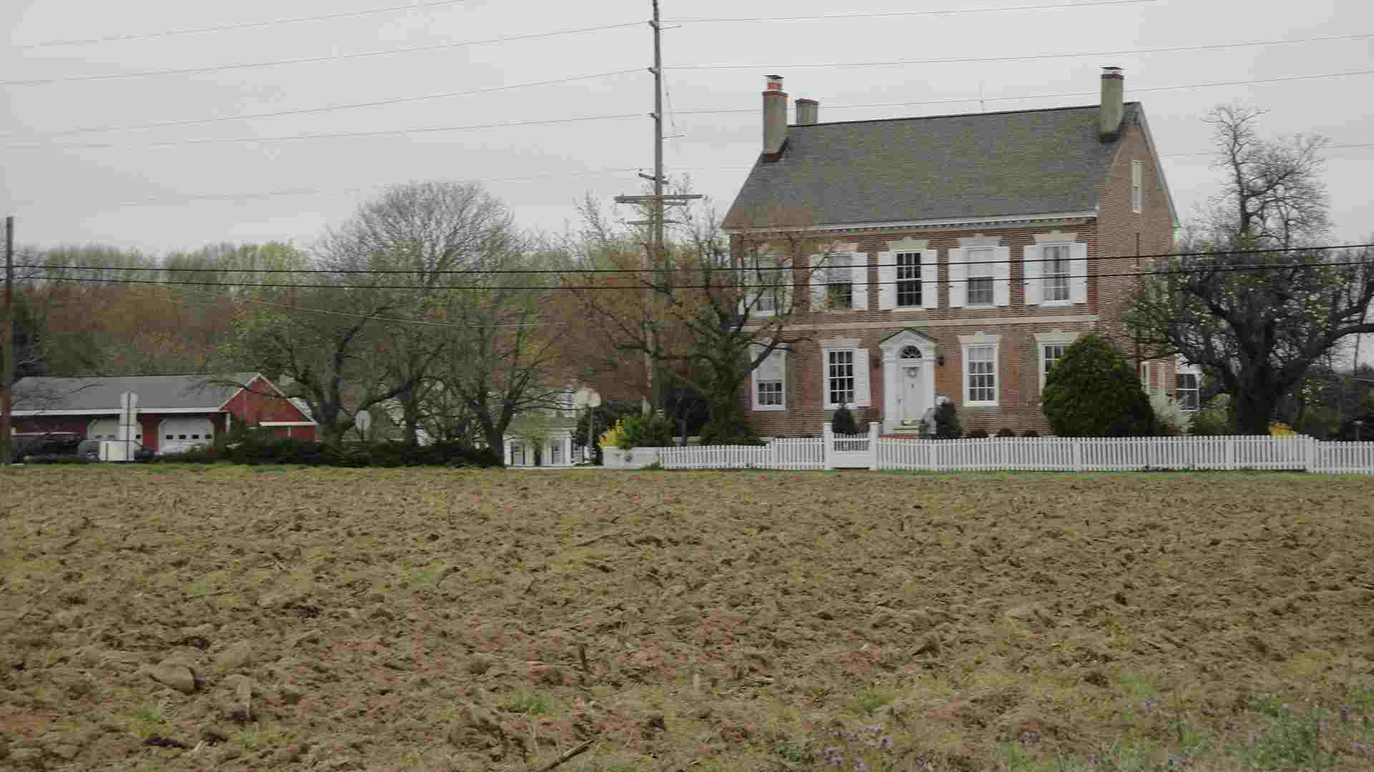
305 Whig Lane

Finally, a feeling of accomplishment and completion was sweeping over me as I drove to my last high point of the day at 185 Swedesboro Road. This was an easy one. I parked my car, no one was about and walked under the large tree at the side of the road and in that instant I had “greened” New Jersey.
Years of dreaming, years of worrying, years of studying maps had come to an end. I had now been to all 21 counties in New Jersey and three counties in Delaware were mine. The “impossible dream” became reality. The exhausting two days of driving about, looking over my shoulder were now over.
I drove home to Long Island triumphantly! I now lay claim to 217 counties and seven green states. Now I’m ready to move on to and “worry” about my next challenge, climb Mt Hood, OR.
To Be Continued….

